Put dip swith on Automatic current cutback (CC mode)
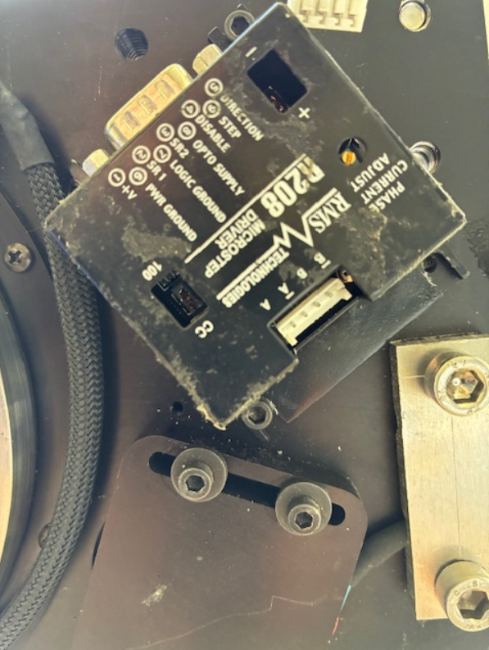
Supply 5V DC into blue pin 8 (Opto supply).
Add +12v external supply voltage to red pin 1 (+V)
Clock signal to yellow pin 9 (Step Clock)

The output current is by default 1,4A
Reduce it to fit the motor parameters. Turn the potentiometers and measure the Voltage Vref.
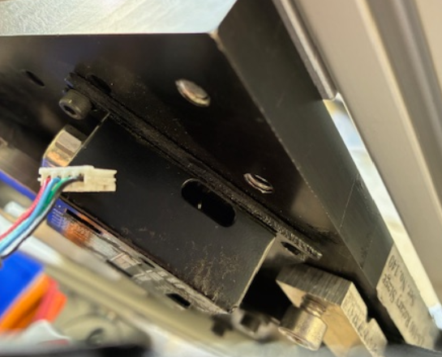
Use this formula: Vref = (I -0.14)/1.554 Where I is the max current of the motor

Ex: Vref must be egual to (0,5-0,14 ) /2.22 = 0.16V for a 0,5A motor.

PIN to control PIN 4+9+5 must be Output SINK.

